CHATTERIS TOWN COUNCIL & FDC GOLDEN AGE
FREE CHRISTMAS PARTY FOR
OVER 75’S CHATTERIS RESIDENTS
29th November 2024
TIME 11.30-15.00
AT
THE KING EDWARD CENTRE, CHATTERIS
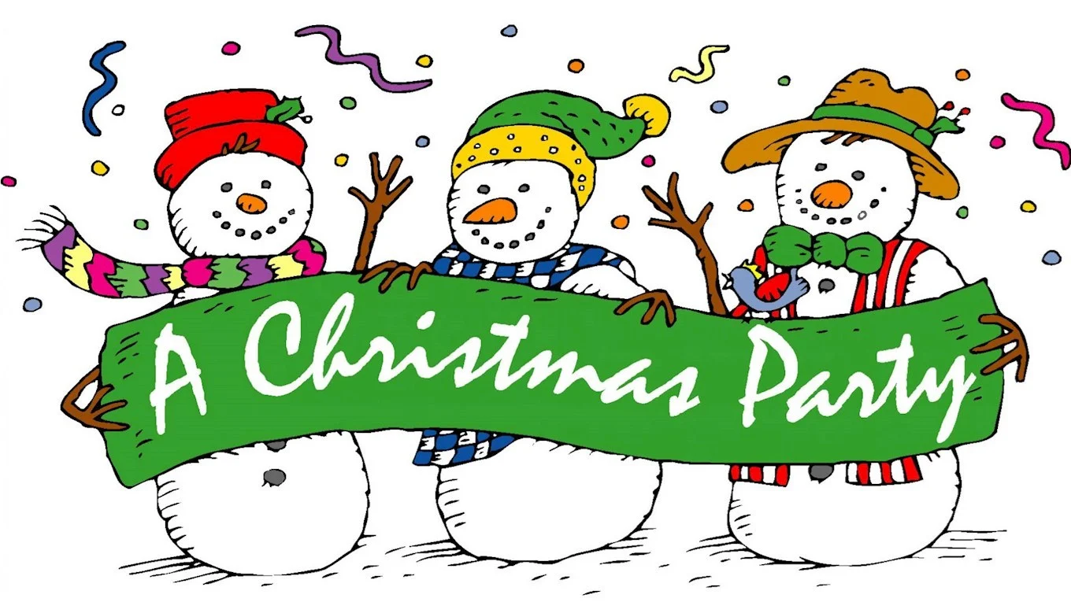
Do you know anyone who is over 75, who would welcome a free Lunchtime Christmas dinner and get together with other residents of the town?
Transport will be provided if required.
There is a maximum of 100 spaces.
To book a place please call 07850749647 or E-mail accounts@chatteristowncouncil.gov.uk
clerk@chatteristowncouncil.gov.uk

